FULL TRANSCRIPT

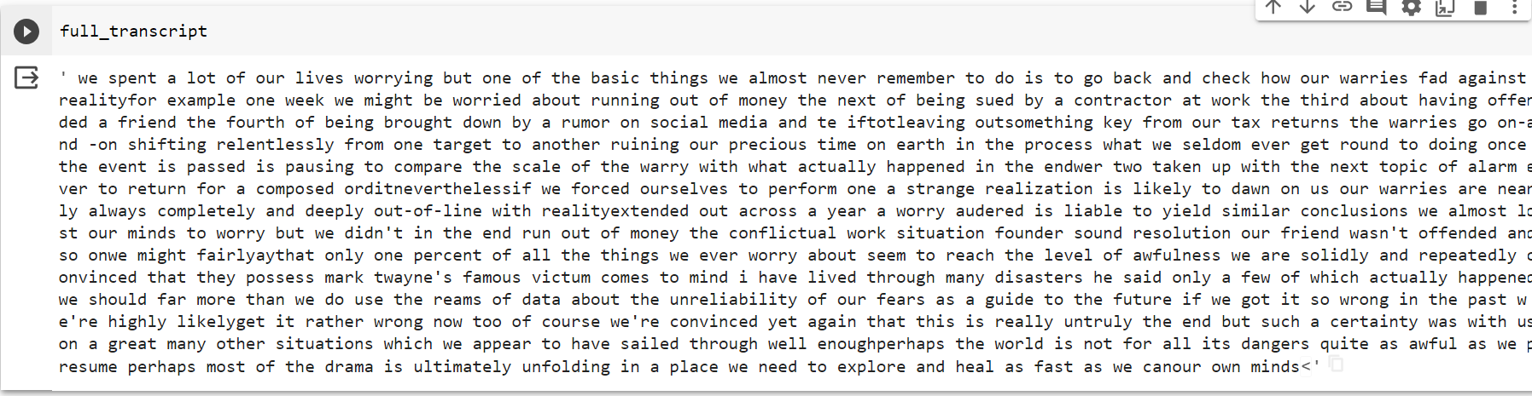

SUMMARIZED TRANSCRIPT

